**Database Practical Week 4**

**What is a business rule, and what is its purpose in data modeling?**

A business rule is a rule that defines how a certain part of the business will work/run. This means that they constrain and limit how things work in the business, usually for efficiency. In data modeling, business rules give us a list of constraints that will need to be considered throughout the design and development of a database. If all the business rules are not gathered at the beginning and are not well defined then the output will produce data that does not reflect the real world data environment correctly which will lead to poorly defined data model, poor database design, poor application, poor decision making, and eventually the failure of the organisation. So it is imperative that the original business rules are all gathered and defined correctly.

**How would you translate business rules into data model components?**

Nouns --> Entities

Verbs --> Relationships

Example:

A customer may generate many invoices

Verb = Generate

Noun = Customer, Invoice

Database Business Rules

Extract the business rules for each of the following scenarios.

**Senario 1**

Each of the MegaCo Corporation’s divisions is composed of many departments. Each of those departments has many employees assigned to it, but each employee works for only one department. Each department is managed by one employee, and each of those managers can manage only one department at a time.

MegaCo has many divisions

Each division is composed of many departments

Each department is run by one manager

Each department has many employees

Only one manager can run one department

Each employee can only work for one department

**Senario 2**

The KwikTite Corporation operates many factories. Each factory is located in a region. Each region can be “home” to many of KwikTite’s factories. Each factory employs many employees, but each of those employees is employed by only one factory.

KwikTite runs many factories.

Each factory is in a certain region

One region can have many factories

Each factory employees many employees

Each employee is assigned to only one factory

**Senario 3**

The Hudson Engineering Group (HEG) has contacted you to create a conceptual model whose application will meet the expected database requirements for the company’s training program. The HEG administrator gives you the description (see below) of the training group’s operating environment: The HEG has 12 instructors and can handle up to 30 trainees per class. HEG offers five “advanced technology” courses, each of which may generate several classes. Each class is taught by one instructor. Each instructor may teach up to two classes or may be assigned to do research only. Each trainee may take up to two classes per year.

HEG has 12 instructors

Each instructor can handle 30 trainees per class

HEG has five different courses

Each course has many classes

Each class is taught by one instructor

Each instructor can teach up to two classes or can be assigned to research instead

Each trainee can take, up to, two classes per year

**Senario 4**

2. The Jonesburgh County Basketball Conference (JCBC) is an amateur basketball association. Each city in the county has one team as its representative. Each team has a maximum of 12 players and a minimum of 9 players. Each team also has up to three coaches (offensive, defensive, and physical training coaches). During the season, each team plays two games (home and visitor) against each of the other teams.

The JCBC consists of many teams

Each city in the country has one team as its rep

Each team has a max of 12 players and a min of 9 players

Each team has up to 3 coaches

Each coach teaches a different area, (offensive, defensive and physical training)

Each team plays twice per season against the other teams

1 game must be played at home

1 game must be played away

Database Business Rules

Extract the business rules for each of the following diagrams.

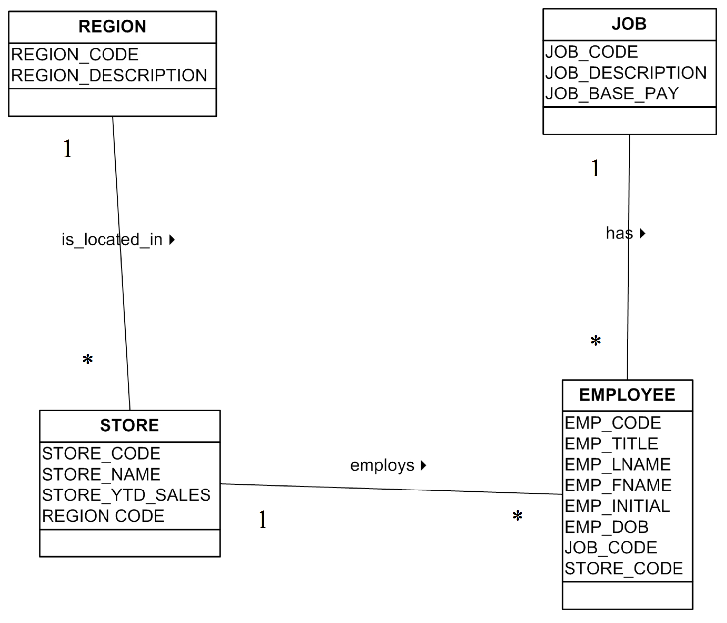

Diagram 1

Bottom of Form

Each region has many stores

Each store has many employees

Each job can have many employees on it

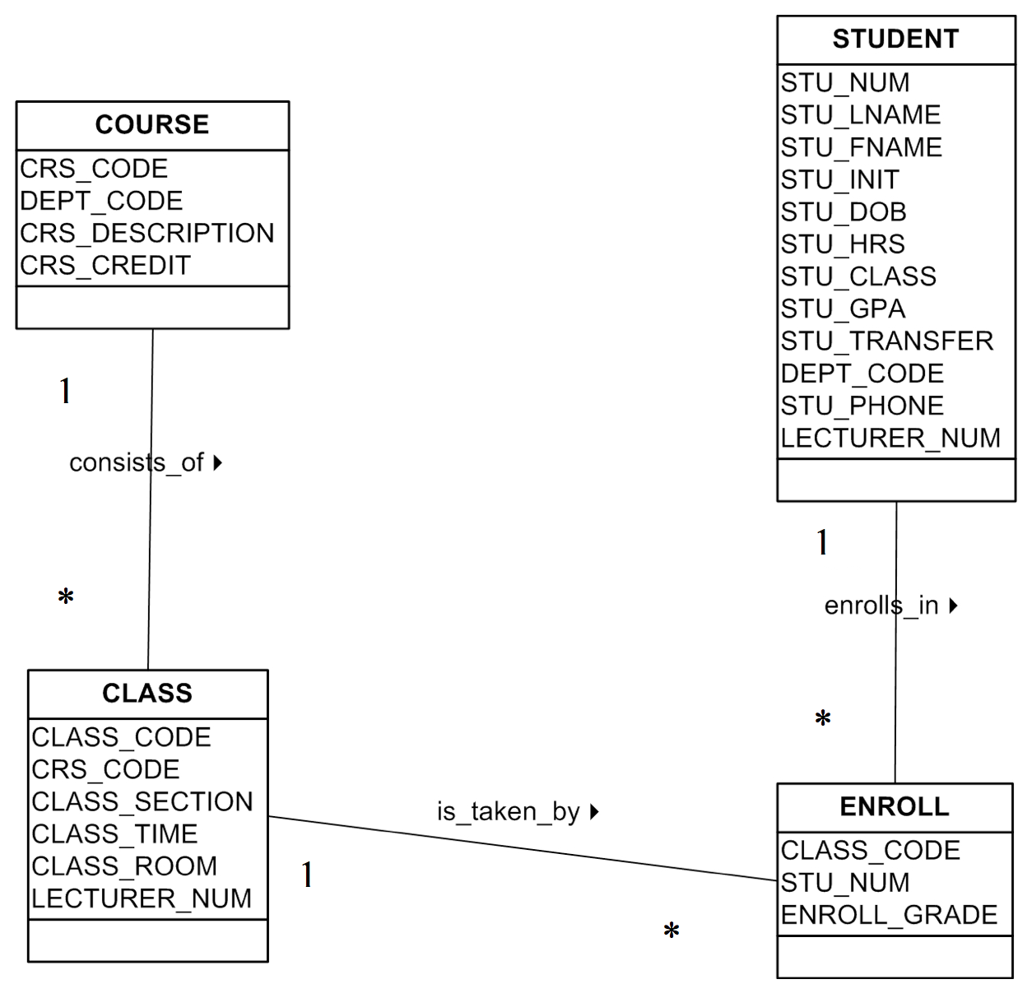

Diagram 2

Each course consists of many classes

Each class has many enrolled

Many students are enrolled